**Annual Progress Report**

# August 2011 – August 2012

[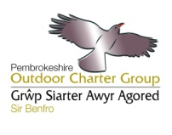](http://www.pembrokeshireoutdoors.org.uk/)**Pembrokeshire Outdoor Charter**Core work of the POC group by Activities Liaison Officer (ALO) has continued to proactively manage the sustainable development of outdoor recreation. All core meetings and events have been achieved on schedule and much additional work has been completed.

* **Outdoor Charter Working Group and Full Group Meetings:**
* The full Pembrokeshire Outdoor Charter meeting was held as part of the Outdoor Recreation Conference at the Liberty Stadium on the 7th March. This event was well attended by the SME’s that populate the adventure activities sector across the whole of South Wales and by WG and was a great success in sharing information, progress updates, and ratifying draft proposals put forward for in support of a Wales Outdoor Recreation Network. Minutes from the conference can been read here: <http://www.swoapg.org.uk/index.php/documents/>
* All OC working group and full meetings held on schedule – minutes of full meetings posted on [www.pembrokeshireoutdoors.org.uk](http://www.pembrokeshireoutdoors.org.uk)
* **Coasteering**
* OC continues to manage conflicts of interest for coasteering. Conflicts continue to arise at

Abereiddy and Ceibwr Bay – monitoring is in place for the season with meetings planned for post

season.

* Filming of Coasteering DVD now complete. The aims to reconcile coasteering and conservation

and an online version of the film can be seen [here](http://www.pembrokeshireoutdoors.org.uk/)

* The code of conduct for coasteering has been further developed under the three headings of

‘Respect, Protect, and Enjoy’ to fit with other codes such as the waterside code produced by CCW. - ALO attended second full National Coasteering Charter meeting in Bristol. 80 coasteering

companies attended, voted through the NCC of best practice, draft written by the ALO.

* **Outdoor Charter Leaflet goes digital**

The new Outdoor Charter website has been launched & information currently on the OC leaflet was reproduced digitally. See the new website [here](http://www.pembrokeshireoutdoors.org.uk/).

* **Cliff Diving World Cup Event planned at Abereiddy**

Met with organisers Red Bull, PCC, CCW and PCNPA and gave advice on site & minimising disturbance to wildlife & provided relevant contacts. Invited Red Bull to present at the full OC meeting. Presented to Pembrokeshire Tourism. Posted information on OC website & Facebook.

* **Kite Sports and Paragliding**
* Kite sports guidelines for best practice were agreed for the season, reprinted, and posted online and in beach notice boards.
* Considerable time spent managing conflicts of interest between Paragliders and farmers / landowners / horse riders in the Preseli Hills.
* Meeting organised to attempt to manage paragliding, however the land owners have now officially reaffirmed their wish that paragliding should not take place on the Preseli Hills due to the potential impact of the sport on grazing, and in turn the SSSI features of the site. Minutes from that meeting can be seen [here](http://www.pembrokeshireoutdoors.org.uk/meetings-progress/) .
* **Sea Kayak Code and DVD project developed.**

Funding sourced to develop a short film on best practice whilst out sea kayaking to minimise impact on the environment and wildlife. Pembrokeshire Marine Code for Kayakers will be spread across Wales in consultation with Canoe Wales and CCW.

* **Personal Watercraft (PWC) Management - South Pembrokeshire**

TL continues to be a point of contact for PWC complaints and will coordinate and follow up reports of incidents. A pre and post season meeting held annually attended by all involved in PWC management.

Visit the website:[www.pembrokeshireoutdoors.org.uk](http://www.pembrokeshireoutdoors.org.uk)

**Pembrokeshire Marine Code (PMC)**Core work of the PMC group has continued to proactively manage the sustainable development of outdoor recreation. All core meetings and events have been achieved on schedule and much additional work has been completed.

* ALO assisted with a detailed case study review of the Pembrokeshire Marine Code in the context of assessing the PMC projects ‘voluntary approach to the management of the marine environment’ for a report prepared by Wales Environment Link on behalf of RSPB. The WEL Report and Case study can be viewed [here](http://www.pembrokeshiremarinecode.org.uk/publications/).
* Completed a 10 year review of the PMC project which can be read [here](http://www.pembrokeshiremarinecode.org.uk/).
* Review, update and reprint MC leaflets. 1000 copies have now been produced.
* Funding Sourced to reprint 10,000 paper copies of the MC leaflets, and 500 waterproof copies for completion by December 2012
* Follow up meetings were held to discuss creating Marine Code signage for South Pembrokeshire due to increased sit on top kayaking, and fast boat activity. Additional funding has been secured from CCW and National Trust to create MC information sign for Stackpole and Freshwater East.
* Marine Code steering group meeting held 23rd July
* **Events held over the last year**
* Wildlife Sightings Event to celebrate wildlife and promote best practice - 200 attendees.
* Scuba Dive Event – 59 attendees organised to raise awareness about the Marine Code and Marine SAC, and develop stronger relations with diving community following development of PCNPA Recreation plan. A second event was run on 25th August and organised in partnership with Haven Diving Services and The Pembrokeshire Marine SAC. 36 people attended, with talks delivered on the Pembrokeshire Marine Code, Marine Wildlife in Skomer MNR and an update on progress with HP MCZ's.
* Attended Careers Event Pembrokeshire College to promote opportunities and training advice for careers in the outdoor sector 20th March.
* Attended Wales Coast Path Launch Event 5th May to promote Outdoor Charter & Marine Code
* Trinity College Event – presentation and walk for 25 FE students. 9th May
* Pembrokeshire Tourism Activity Tourism Event attended. 15th May – presentation, stand & workshops delivered for tourism members.
* Stackpole Rediscovered Event launch attended 21st May
* Pembrokeshire Sea Kayak Festival Attended – presentation and stall delivered on ‘paddling lightly’ & the Pembrokeshire Marine Code. 1st June
* University of East Anglia Visit - Oriel Y Parc presentation and talk to students.
* Fish Week Launch Event attended with stall. 23rd June
* Assisted with facilitation of HPMCZ public engagement events in North and South Wales.
* Attended Coastal Engagement Toolkit event 24th July.
* Manned PCC Beaches Unit at Whiteland’s to liaise with the general public 9th August.
* Treffgarn Environmental Training day Event organised for the Pembrokeshire Outdoor Charter group at Treffgarn for Climbers and Kayakers using the quarry to ensure best practice on 24th August - 10 instructors attended (poor numbers due to really bad weather). Covered Geology, History and Archaeology of the Treffgarn area, and established best practice when working in the area with activity groups.

**Representing Activities Sector / Sharing Best Practice:**

* **Pembrokeshire Tourism**
* ALO attended a Pembrokeshire Tourism Activities and Attractions meeting, continuing to represent the Outdoor Recreation sector and passed on the OC group details about grants and funding available such as LIF, TISS, Digital funding available, and Update from PCC on visitor survey.
* Strategy day and board meeting attended as representative of outdoor sector.
* Provided feedback on PCC Destination Management Plan 2012 - 17
* **WATO, WORN & Visit Wales**
  + ALO continues to share best practice for the sustainable development of outdoor recreation through the Wales Activity Tourism Organisation (WATO), and a work plan for 2012 – 15 has been prepared to secure further funding for this work. Funding for 2013 is in place for WATO.
  + Quarterly WATO meetings attended
  + WATO have produced a draft proposal for a Wales Outdoor Recreation Network, (WORN) now finalised & posted to Welsh Government & online.
  + Website now up for WATO & WORN here: [www.wato.org.uk](http://www.wato.org.uk)
  + Follow up meeting held with Minister for the Environment John Griffiths to discuss WATO progress & WORN proposals – encouraging feedback received - likely to lead to a meeting to forge a way forward with the new chair of the Natural Resources Wales organisation in early 2013
  + ALO assisted Visit Wales to update surfing and rock climbing photos for North Pembrokeshire.
  + ALO attended a Task and Finish meeting with Visit Wales to work on improving the profile of wildlife tourism opportunities in Wales. Assisted with production of a ‘Sustainable’ top 10 wildlife experiences in Wales for Spring summer, and a top 10 for Autumn winter.
  + Attended Wildlife Tourism working group meeting 15th August
* **SWWMLF**
* ALO continues to represent the interests of the Marine Code group on the South West Wales Marine Leisure Federation steering group.
* Work completed in partnership with SWWMLF to produce 9 x wildlife appreciation sheets aimed at Marina users to raise awareness of the Marine Wildlife around Wales, and best practice when viewing marine wildlife. 14,000 hard copies distributed across Wales. Digital versions can be seen [here](http://www.irish-sea.org/wales-marine-wildlife-appreciation)
* **Publicity of PMC and POC:**
* MHPA Networking event presentation – 200 local businesses and key stakeholders present.
* Morning broadcast about the work of the POC and PMC groups on Radio Pembrokeshire
* Employed as the consultant for filming with ITV for new series ‘Adventure Guide to Britain’
* Assisted with preparation of articles for Coast to Coast
* Prepared article for Pembrokeshire Magazine
* Developed social media sites for Outdoor Charter
* Launched and updated the new OC and MC group websites
* Press release for Wildlife Sightings Event prepared
* Websites Updated:

Visit the website:

[www.pembrokeshireoutdoors.org.uk](http://www.pembrokeshireoutdoors.org.uk)   
[www.pembrokeshiremarinecode.org.uk](http://www.pembrokeshiremarinecode.org.uk)

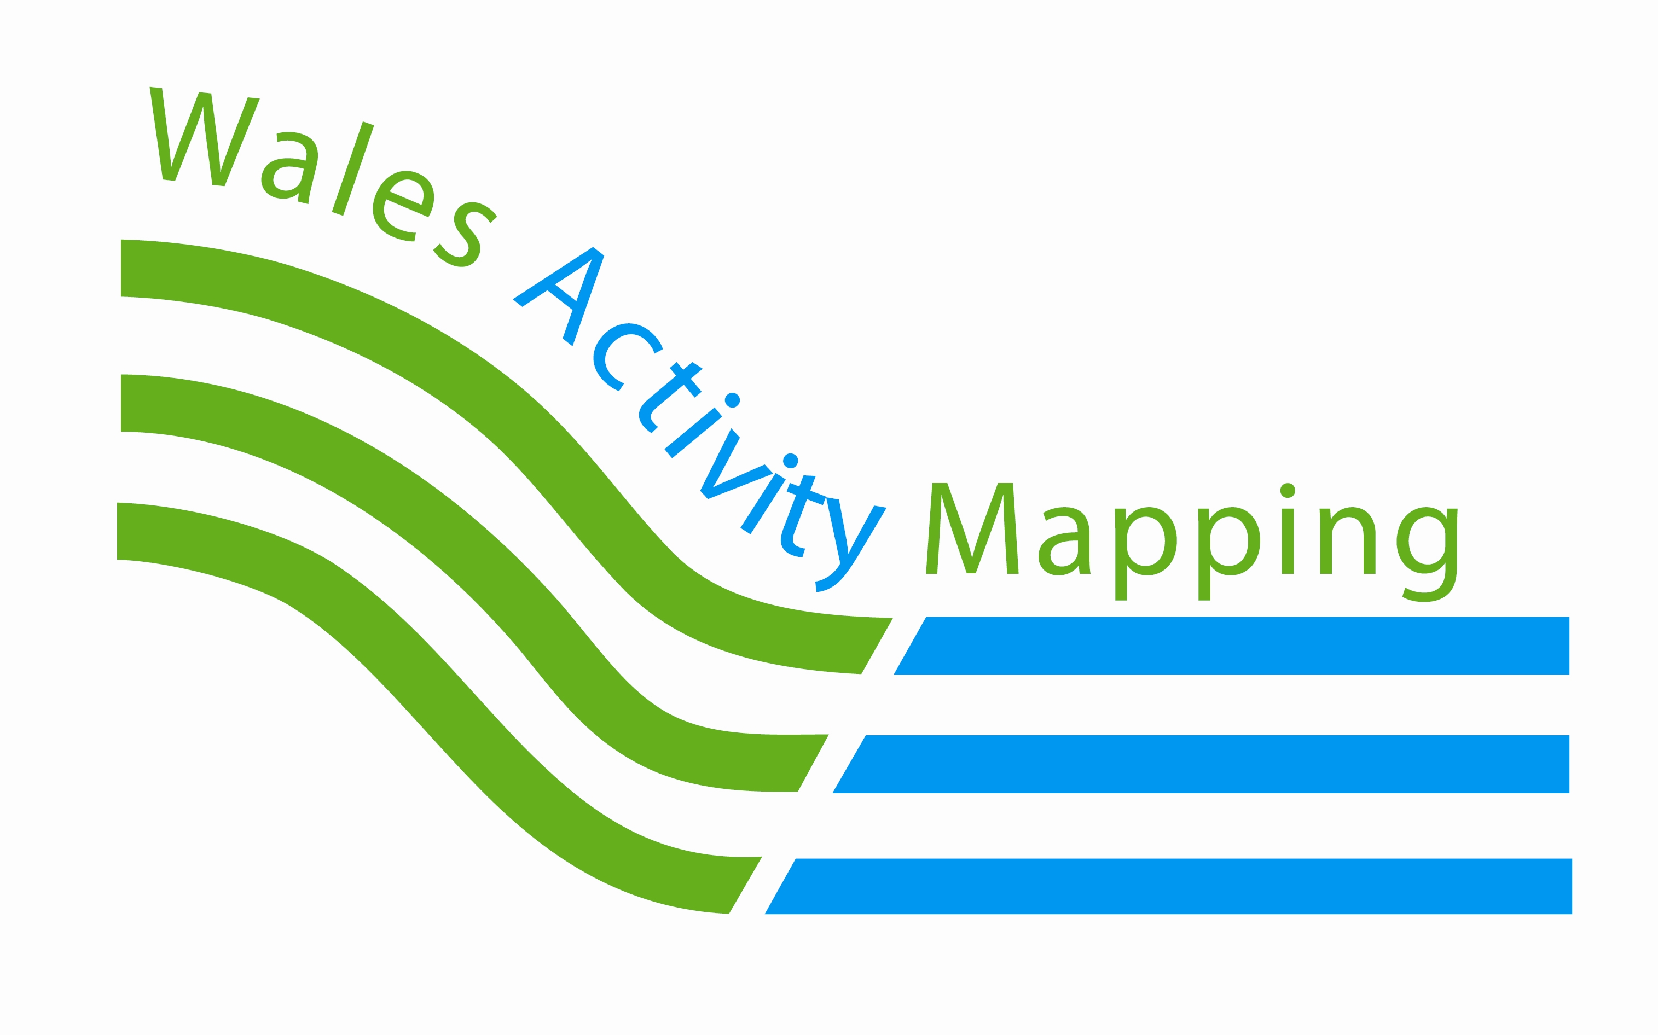

**Wales Activity Mapping**

DJ works on the Wales Activity Mapping (WAM) project in a limited capacity due to regional funding. The project has seen a wide range of uses across various sectors including

* Tidal Energy Limited for EIA of a tidal turbine at Ramsey sound
* Consultants for a number of projects e.g. Land Use Consultants for the Marine Conservation Zones Project/Finding Sanctuary
* WG has used the data for their upcoming Marine Renewable Energy Strategic Framework/Coastal Tourism Project/Recreation Planning Toolkit/ Destination Management toolkit and Coastguard station coverage.
* DECC for their Marine Action Plan
* PCNPA for the Recreation Plan and public facing “Enjoy” website
* Carmarthen Bay and Estuaries European Marine Site for a Management Plan
* SWWMLF to identify the number of slipways and mooring sites
* Bridgend for Beach Management Plans
* PCC for Blue Flag award process
* The National Trust/Outdoor Charter to proactively take a holistic view of developing commercial coasteering and licensing.
* MCS for an angling bin project
* Valleys Regional Park looking at sustainable tourism development
* A Plans and Projects section showing consenting and planning within the Pembrokeshire Marine SAC.

DJ has recently been part of a successful tender bid by Landsker Business Consultants to look at a pilot scheme within the Valleys Regional Park (VRP) and mapped two areas of recreational interest using the WAM system and methodology. A report for a phased approach was presented to the VRP management team including the mapping of outdoor recreation opportunity. Positive feedback on the work has culminated into a possible expansion into the wider VRP and South East Wales Spatial Plan area.

DJ is also part of a joint tender bid to Defra with Marine Planning Consultants, Atkins and Plymouth Marine Lab looking at the VALUE OF THE IMPACT OF MARINE PROTECTED AREAS ON RECREATION AND TOURISM SERVICES in England. The WAM project has been recommended to the MMO by MPC Consultants studying coastal recreation in Marine Planning areas in England.

A funding bid is being developed and led by DJ in collaboration with MPC, Atkins and Plymouth Marine Lab to value coastal recreation in two pilot areas (Dale and St David’s Head). If the bid is successful the project will put a value to activity and areas mapped within the WAM project and provide methods to expand the process beyond Countywide.

Meetings with CCW recreation Policy team have taken place exploring hosting habitat venerability mapping and pan Wales expansion.

Demonstrations of the GIS website have been given at both Regional and National levels and have included

* Local Authorities from the study area
* CCW
* Pembrokeshire Coast National Park Authority
* National Access Forum for Wales
* WAG Coastal Tourism Team
* Welsh Activity Tourism Organisation
* CRN
* Pembrokeshire MC/OC working groups
* Marine Conservation Zone Stakeholder Engagement Group
* VRP
* South East Wales Tourism Partnership
* Workshop at the Liberty Stadium Swansea for Visit Wales

Feedback from all demonstrations has been positive.

For more in depth information see the Project Progress Report for more details. <http://www.walesactivitymapping.org.uk/reports-3/>

Visit the website: [www.walesactivitymapping.org.uk](http://www.walesactivitymapping.org.uk)

**Coasteering Feasibility Management project**

The Coasteering Feasibility Mapping Project is looking at the sustainable use of the coastline in Pembrokeshire for commercial coasteering.  This sector has grown rapidly in recent years.  In response, activity providers are seeking access to new stretches of coast for this activity, whilst local management systems are being established by landowners at existing venues.   There is a need to guide the expansion of this activity and manage the attendant environmental risks.  The Coasteering Feasibility Mapping Project takes a holistic view of the coastline and a proactive approach to identifying suitable areas that may have the potential to accommodate commercial coasteering activity.

The project involves data collection of sensitive features that may be impacted upon by the activity. GIS layers and data have been collated on species such as Peregrine, Chough, Seals, Sensitive Biotopes, Geological features, Conservation designations and Wildness. These have been overlain on maps with expert advice provided from project partners including CCW, The National Trust, The National Park Authority and SAC officers. The Feasibility layer is now complete with agreement on commercial development with activity centers the final stage.

**PCNPA Recreation Plan**

DJ has been involved in the development of a Recreation Plan for PCNPA. This process has involved co-writing the Plan and carrying out the consultation process. Over 60 responses were received. A consultation response paper is complete, the Plan formally launched and relevant content utilised within PCNPA Supplementary Planning Guidance. The Wales Activity Mapping project has been used as an evidence base for the Plan.

**Recreation Toolkit**

In addition to developing the Recreation Plan DJ has been working with CCW, PCNPA and Visit Wales to develop an Integrated Recreation toolkit. The toolkit combines the WAM project, [Recreation Plan](http://www.walesactivitymapping.org.uk/recreation-plan/) and the [PCNPA Enjoy Recreation website](http://enjoy.pcnpa.org.uk/new_site/default.asp?pid=2) and is now part of part of Welsh Government’s [Destination Management Toolkit](http://www.dmwales.com/).



**Pembrokeshire Coastal Forum** *Fforwm Arfordir Sir Benfro*

The Old Sail Loft, *Yr Hen Lofft Hwyliau*Milford Docks, *Dociau Aberdaugleddau*Milford Haven, *Aberdaugleddau*SA73 3AF  
**T**  (01646)696171 **E**[PCF@mhpa.co.uk](mailto:PCF@mhpa.co.uk)    **W** [www.pembrokeshirecoastalforum.org.uk](http://www.pembrokeshirecoastalforum.org.uk)