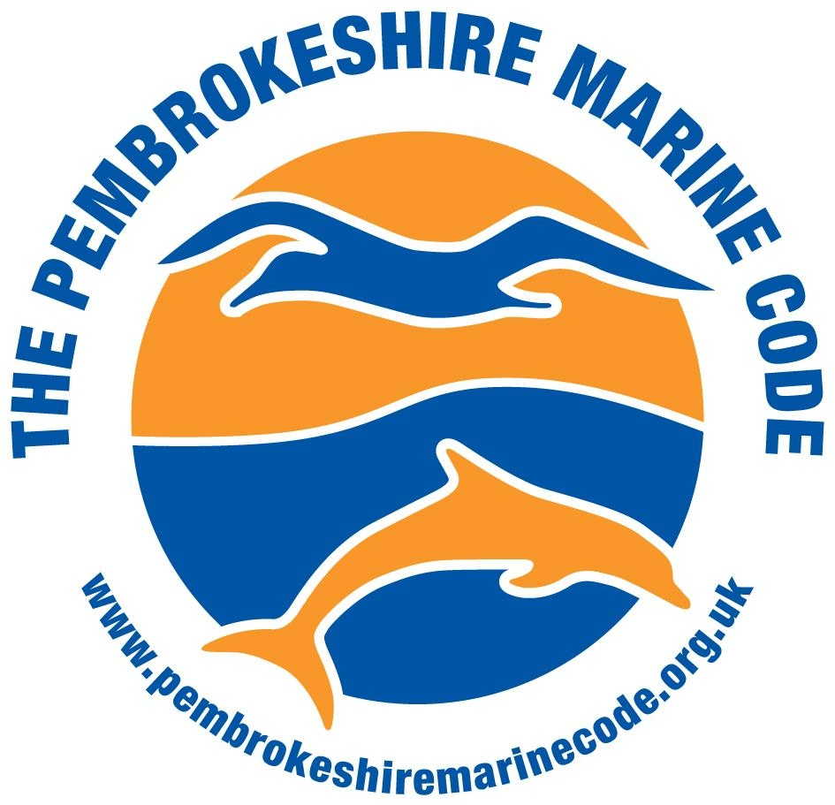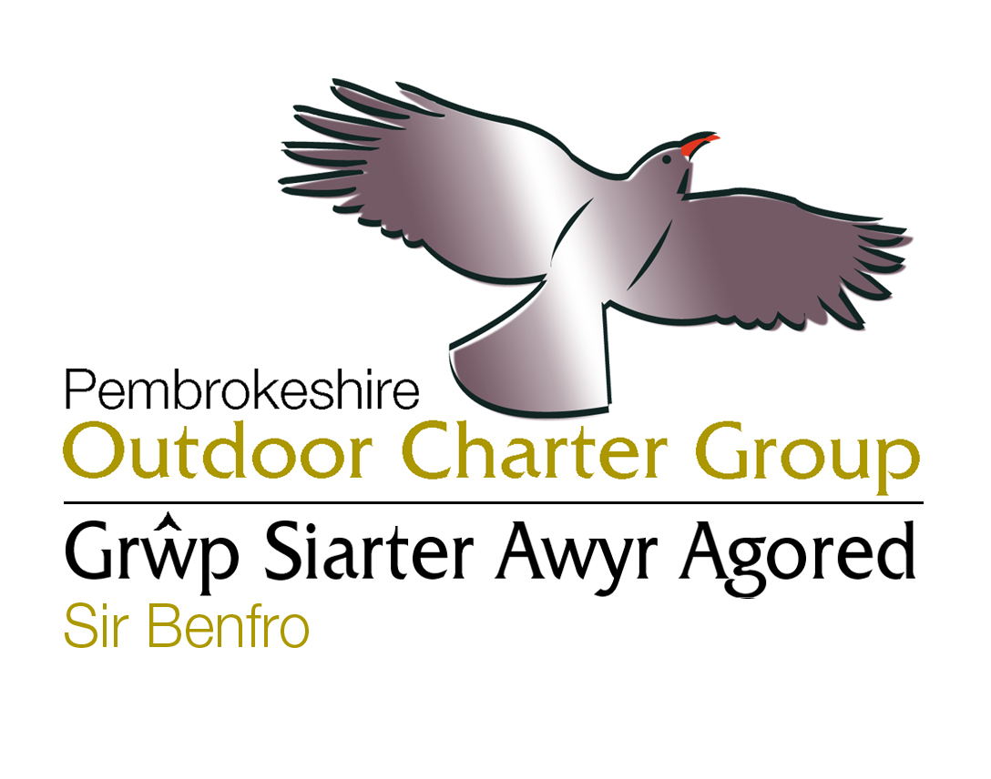Marine Code/Outdoor Charter
Progress Report
21st July – 3rd November 2011

Summary:
During this quarter, core work of the PMC and POC group has continued to proactively manage the sustainable development of outdoor recreation, with all core meetings achieved. Good progress has been made on the preparation of a short video and code of conduct for guides to reconcile coasteering and conservation, and a successful event for divers was facilitated with 59 attendees.

Links with Visit Wales and the sharing of best practice continues through the Wales Activity Tourism Organisation, and a draft proposal for a Wales Outdoor Recreation Network has been prepared for Welsh Government and CCW. ALO has assisted with updating the VW photo library of climbing & surfing in North Pembrokeshire. The new OC website has been officially launched, and social media sites developed. Other publicity of the MC and OC has included engaging with ‘Radio Pembrokeshire on Tour’ showcasing the work of the groups, and ITV filming for ‘Adventure Guide to Britain’. The PCNPA Recreation Plan has now been published, and the Outdoor Charter group has been recognised in the plan as being a proactive partnership approach to managing outdoor recreation which the PCNPA will continue to support - which is good news!

- Outdoor Recreation Management work this quarter:

Outdoor Charter Working Group and Full Group Meetings:

- Working group meeting held 12th October – Action points identified and agenda set for the forthcoming full OC meeting.
- Full OC group meeting held 3rd November at Newgale YMCA OEC. Good attendance. Minutes can be seen here.

Coasteering:
- Meeting to resolve conflicts of interest at Ceibwr Bay regarding increased usage of the bay by coasteering groups.
- Filming of Coasteering DVD to reconcile coasteering and conservation at various locations with a whole range of experts including representatives from CCW, PCNPA, NT, Marine Biologist, Seal Expert and filming on location at Stackpole, St Nons, Porth Llisky, and Trearddur Bay in North Wales. This DVD will form part of a suite of DVD’s on best practice for outdoor pursuits.
- The code of conduct for coasteering has been further developed under the three headings of ‘Respect, Protect, and Enjoy’ to fit with other codes such as the waterside code produced by CCW.

Diving:
Dive Event – organised to raise awareness about the Marine Code and Marine SAC, resolve conflicts of interest, and develop stronger relations with the diving community following the development of the PCNPA Recreation plan – 59 attendees

Cliff Diving World Cup Event planned at Abereiddy
Met with organisers Red Bull, PCC, CCW and PCNPA and gave advice on site & minimising disturbance to wildlife & provided relevant contacts. Invited Red Bull to present at the full OC meeting, to reduce any conflict between operators, event organisers and conservationists.

Kite Sports and Paragliding
Kite sports guidelines for best practice were agreed for the season, reprinted, and posted online and in beach notice boards.

Personal Watercraft (PWC) Management - South Pembrokeshire
TL continues to be a point of contact for PWC complaints and will coordinate and follow up reports of incidents as appropriate a pre and post season meeting is held annually to discuss any outstanding issues and is attended by all those involved in PWC management.

Marine Code
Follow up meetings were held to discuss creating Marine Code signage for South Pembrokeshire due to increased sit on top kayaking, and fast boat activity. A small amount of additional funding has been secured from CCW and National Trust to create a new MC information sign for Stackpole and Freshwater East to raise awareness about the sensitive wildlife there for all watercraft users.

- Representing Activities Sector / Sharing Best Practice:

Pembrokeshire Tourism
TL continues to represent the Outdoor Recreation sector in Pembrokeshire as a Director for Activities at Pembrokeshire Tourism meetings. TL continues to report to Pembrokeshire Tourism on the importance of the sustainable development of outdoor recreation in Pembrokeshire and on current progress and issues / training needs of the sector.
ALO also attended an Activities and Attractions meeting, and passed on the OC group details about Grants and funding available such as LIF, TISS, Digital funding available, and Update from PCC on visitor survey.

WATO & Visit Wales
  - ALO continues to share best practice for the sustainable development of outdoor recreation through the Wales Activity Tourism Organisation, and a work plan for 2012 – 15 has been prepared to secure further funding for this work.
  - WATO have produced a draft proposal for a Wales Outdoor Recreation Network, which will be finalised and posted to Welsh Government and CCW next quarter.
  - ALO assisted VW to update surfing and rock climbing photos for North Pembrokeshire.
  - ALO attended a Task and Finish meeting with Visit Wales to work on improving the profile of wildlife tourism opportunities in Wales. It was agreed to produce a top 10 wildlife experiences in Wales for Spring summer, and a top 10 for Autumn winter. Criteria for the selection of the top 10 was identified to ensure that they were fairly chosen, representative of the diverse range of wildlife experiences available, and geographically well spaced out where possible across the whole of Wales.

SWWMLF
ALO continues to represent the interests of the Marine Code group on the South West Wales Marine Leisure Federation steering group. Currently developing an idea to work in partnership with SWWMLF and the Green Blue to produce an information sheet aimed at Marina users to raise awareness of the Marine Wildlife around Wales, and best practice when viewing marine wildlife.

Beaches Liaison Meetings
ALO attends pre and post season beaches liaison meetings to represent the activities sector with a focus on the management of all beach activities such as wind sports and reporting on the PWC management group progress and incidents.

- Pembrokeshire Coastal Forum Work
ALO continues to work one day a week on Pembrokeshire Coastal Forum core work.
- ALO prepared a progress report and presented to the steering group
- Attended Team Briefing
- Facilitated a Buzz Club Schools event in North Pembrokeshire on Sustainable Tourism.
- Planned and advertised 4 events for MHPA for Buzz Club involving the MCGA and Police Marine Unit
- ALO Attends the MHPA environmental management meetings on behalf of hosted organisations

Funding
- Prepared an indicative bid to CCW for 2012-13 for MCOC projects
- Managed finances for MC and OC projects.
- Funding secured for reprint of MC leaflet from South Hook and Valero

Publicity:
- Morning broadcast about the work of the POC and PMC groups on Radio Pembrokeshire
- Employed as the consultant for filming with ITV for new series ‘Adventure Guide to Britain’
- Assisted with preparation of articles for Coast to Coast
- Developed social media sites for Outdoor Charter
- Launched and updated the new OC and MC group websites:

www.pembrokeshireoutdoors.org.uk
www.pembrokeshiremarinecode.org.uk

